Audition Form  ~ Summer 2025 ~ | 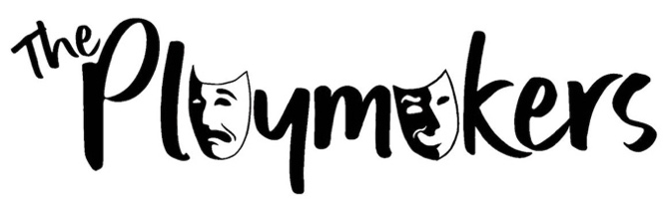

We are delighted to announce that the Sumer Productions will be:
- “Anger Management” written by Robert Scott, directed by Jessica Eade
- “Nickers” written by Robert Scott, directed by Stephen Turner, assistant directed by David Barnes
- “Air Today, Gone Tomorrow” written and directed by Matt Champion

DATES
The performance dates are Friday 20th and Saturday 21st June 2025.
The dress rehearsal will be Thursday 19th June 2025.
The technical rehearsal will be Sunday 15th June 2025.
The get in and set build will be Saturday 14th June 2025.
Weekly rehearsals will be on Monday evenings and Sunday daytimes.

OTHER INFO
Show fees are to be discussed at the AGM. This fee must be paid by the last Monday before the show starts either to the Treasurer or through our website.

Just a reminder that photos and videos will be used for promotion of the show and Playmakers. If you have not completed a video and photo release form please ask a member of the committee for a copy.

AVAILABLE ROLES

“Anger Management” | “Nickers” | “Air Today,  Gone Tomorrow”
Dr Clarke | Nibble | Graham
McGowan | Piffle | Keith
Polston | Squiggle
Knifton | Dungus
Losh | Old McCarther
Ford

Please indicate up to three roles below in order of preference.
Please note that filling out this form is no guarantee of a part.
We are limiting everyone to two parts but we are asking for three preferences to accommodate everyone as much as possible.

***By completing this form and partaking in auditions, you are committing to the dates above and committing to attending every rehearsal you can unless in the case of exceptional circumstances***
Please consider this carefully before filling out the audition form

First Preferred Role: ________________________________________________________
Second Preferred Role: ______________________________________________________
Third Preferred Role: _______________________________________________________

Is there any other information, such as holiday dates, work commitments, etc. that may interfere with your abilities to perform or attend rehearsals?
_________________________________________________________________________________________________________________________________________________________________________________________________________________________________

Will you accept a Character you may not have auditioned for?
[ ] Yes [ ] No [ ] Maybe

If you are unsuccessful at auditions, would you consider being a part of the crew?
[ ] Yes [ ] No [ ] Maybe

Is there anything else you wish the Casting Panel to know?
_________________________________________________________________________________________________________________________________________________________________________________________________________________________________

I ________________________________ ^{[print name]} confirm that I have read the above information and am able to commit to the rehearsals and performances of the Summer 2025 Production.

Signature: _______________________________ Date:___________________

Please return your completed form (digitally or handwritten via a photo) to Fiona Wassan or Jessica Eade, ideally by Sunday 6pm. Thank you

Extra rehearsals may be added at the Director’s discretion
At the discretion of the audition panel, you may be offered an alternative part.

